**Objectives of Futsal Booking System:**

* Dynamic Mobile App: Use Flutter to build a responsive app that prioritizes a seamless user experience for easy futsal court reservations.
* Robust Backend System: Using Laravel, create a dependable backend architecture to effectively manage user reservations, court availability, and vendor interactions.
* Real-Time Updates: Make sure users have accurate information to make well-informed booking selections by providing them with up-to-date information about court availability.
* User-Centric Features: Align the app with the requirements and preferences of the user by introducing amenities selection, team development, and in-app communication.

## DFD (Data Flow Diagram)

### Context Level Diagram

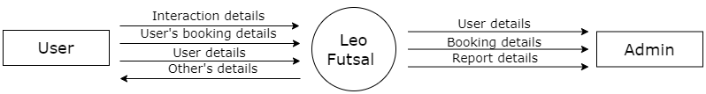

### DFD Level 2 - Registering User

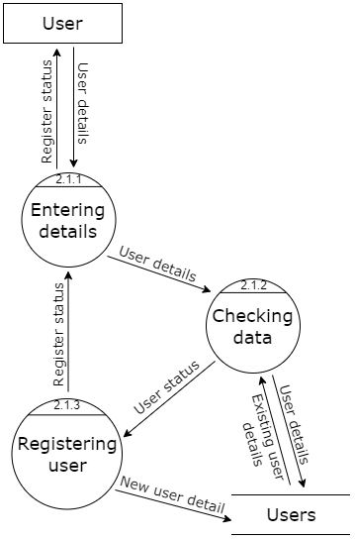

### DFD Level 2 - Login User

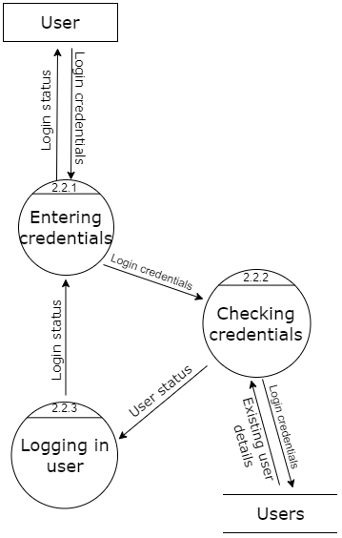

### DFD Level 2 - Court Booking

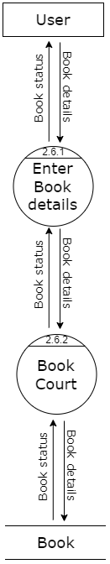

### DFD Level 2 - Make Payment

